**Data Structure**

**Tutorial 5: U19CS012**

Question 1:

You are given an array of integers A, you need to find the maximum sum that can be obtained by picking some non-empty subset of the array. If there are many such non-empty subsets, choose the one with the maximum number of elements. Print the maximum sum and the number of elements in the chosen subset.

**Input:**

No of Elements: N

Set of N elements: A[i]

**Output:**

Sum

Set of elements involved in the sum

**Constraints:**

1≤N≤105

−109≤Ai≤109

**SAMPLE INPUT**

5

1 2 -4 -2 3

**SAMPLE OUTPUT**

6     3

**Explanation**

The chosen subset is {1, 2, 3}.

1.) Algorithm & Dry Run



2.) Code

*#include* <stdio.h>

long long int arr[100001];

*// At Max = 1e5 Elements*

typedef long long int ll;

*// Since -1e9<=A[i]<=1e9*

int main()

{

    int n; *// Number of Elements*

    scanf("%d", &n);

    ll sum = 0;      *// Max Sum*

    int ele_cnt = 0; *// Elements in Sub-Set*

    ll min = -1000000001;

*// for Finding Highest -ve Number [Edge Case]*

*for* (int i = 0; i < n; i++)

    {

        scanf("%lli", &arr[i]);

*if* (arr[i] >= 0)

        {

            ele_cnt++;

            sum += arr[i];

        }

*else*

        {

*if* (arr[i] > min)

                min = arr[i];

*// To Handle Edge Case When All Numbers are Negative*

        }

    }

*// If All Elements are Negative, then ele_cnt = 0*

*if* (ele_cnt != 0)

        printf("%lli %d", sum, ele_cnt);

*else*

        printf("%lli %d", min, 1);

*return* 0;

}

3.) Test Cases

A.) Sample Test Pass [Positive + Negative]

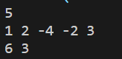

B.) Postive + Zero + Negative

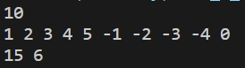

C.) Zero + Negative

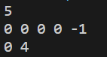

D.) All Negative Numbers

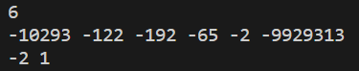

Question 2:

Given: Two array of integers **A, B, in Decreasing Order**. Create a Mad Array M, where

Madness of two numbers = **M (A[i], B[j]) = j - i**, if j >=i and B[j] >= A[i],

                                                                     = 0 otherwise.  
Final Madness Mad **(A, B) = max (M (A[i], B[j])) for 0≤ i, j< n-1.**

**Input Format:**   
Input size of an array (Both array are of same size)

Input both array (values in Descending order)

**Output format:**   
Print the madness of the two arrays.

**Constraints:**   
1 <= Test Cases <= 50  
1 <= N <= 105  
1 <= Ai, Bi <= 1012

**SAMPLE INPUT**

1

9

7 7 3 3 3 2 2 2 1

8 8 7 7 5 5 4 3 2

Sample Output

5

Sample Input

1

6

6 5 4 4 4 4

2 2 2 2 2 2

**SAMPLE OUTPUT**

0

**Explanation**

In the first case, we can see that 3 in the second array is the number which is equal to the 3 in the first array, and the difference between their positions is 5. So, the answer is 5.

1.) Algorithm & Dry Run



2.) Code

*#include* <stdio.h>

long long int a[100001], b[100001];

*// At Max = 1e5 Elements*

*#define* max(a, b) (a < b ? b : a)

int main()

{

    int test; *// Number of Test Cases*

    scanf("%d", &test);

*while* (test--)

    {

        int n; *// Size of Both Array [A & B]*

        int madness = 0;

        scanf("%d", &n);

*for* (int i = 0; i < n; i++)

        {

            scanf("%lli", &a[i]);

        }

*for* (int i = 0; i < n; i++)

        {

            scanf("%lli", &b[i]);

        }

*for* (int i = 0; i < n; i++)

        {

*for* (int j = i; j < n; j++)

            {

*if* (b[j] >= a[i])

                {

                    madness = max(j - i, madness);

                }

*else*

                {

*break*;

*// Since it is Non-Decreasing Sequence*

*// we wont find any b[j] >= a[i] further*

                }

            }

        }

        printf("%d\n", madness);

    }

*return* 0;

}

3.) Test Cases

A.) Sample Test

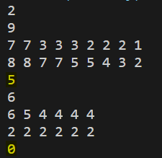

B.) Another Test [There is no j that follows the Condition]

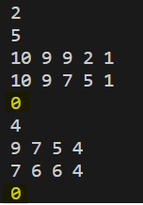

C.) Another Test [i=2 & j=2 in Test 1 and i=4 & j=6 in Test 2]

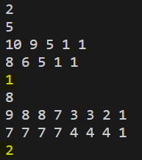

Submitted By:

Roll Number: **U19CS012** (*D-12*)

Name: *Bhagya Rana*